* Author: Navin Chaganti

* Graduate Student

* Software Engineering Concept

* ECE-573

* University Of Arizona

Reference:

http://www.tutorialspoint.com/android/android_google_maps.htm

Integrating Google Maps

Integrating google maps in your application basically consists of these 3 steps.

1. Download and configure. Google Play Services SDK
2. Obtain API key from google console
3. Specify Android Manifest settings

## Download and configure. Google Play Services SDK

### **INSTALL GOOGLE SERVICES SDK**

Open your SDK manager in the eclipse by clicking the Window and then selecting the Android SDK manager.

Navigate to the extras tab and select the Google play services and click on install this package. It would be like this.

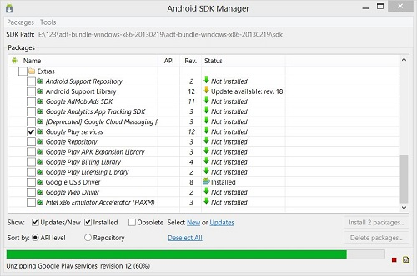

### **IMPORT SDK TO ECLIPSE**

After you download the SDK , click on file tab and select import option. Select existing android application code and press ok. Browse to your android folder and then sdk folder. In sdk folder expand extras folder. Expand google folder and select google play services.

### **CONFIGURE YOUR PROJECT WITH SDK**

After you import the SDK , you have to add it into your project. For this , right click on your eclipse project and select properties. Select android from left tab and then select add from right below panel and add the project. It would be like this

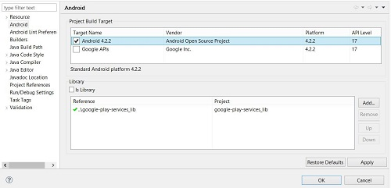

## Obtaining the API key

This part is furthur divided into two steps. First you have to get an SHA1 fingerprint key from your pc and then you have to get map API key from google console.

### **GETTING CERTIFICATE FROM KEYTOOL**

You need to get a certificate key because you have to provide it to google console in order to get your API key for map.

Open your command prompt and move to the path where your java jre has been placed. Now type this command.

keytool -list -v -alias androiddebugkey -keystore %%Your path%% -storepass android -keypass android

Replace the percentage part of the command with the path which you will copy from by selecting the window tab and selecting the preferences tab and then selectng the build option under android from left side.

Copy the default debug keystore path and replace it in the cmmand and hit enter. The following result would appear.

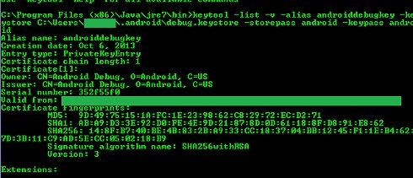

Copy the SHA1 key because you need it in the next step.

### **GETTING KEY FROM GOOGLE CONSOLE**

Open [Google Console](https://code.google.com/apis/console/) and sign in by clicking a new project.

Click on services from the left tab and then navigate to the Google Maps Android API v2. You have to turn them on like this

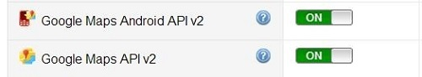

Now again go to the left tab and select API access. And click on create new android key. Now paste the key that you copied and put a semicolon and paste your project name and click create. It would be like this.

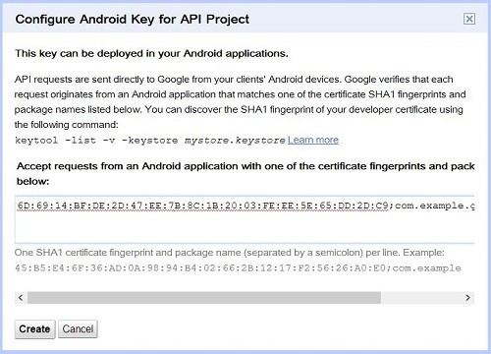

Now copy the API key that has been given to your by android , because you have to paste it into your manifest file.

## Specify Android Manifest settings

The final step is to add the API key to your application. Open your manifest file and place this code right before closing the application tag.

<meta-data

android:name="com.google.android.maps.v2.API_KEY"

android:value="API_KEY"/>

In the second line replace API_KEY with your api key and you are done. You need to add some permissions in your manifest too which are given below in the manifest file.